A

Project Report on

**STOCK MARKETS**

Submitted in partial fulfillment of completion of the course

Advanced Diploma in IT, Networking and Cloud

Submitted by:

**Sajan Sharma**

**Payal**

|  |  |  |
| --- | --- | --- |
| IBM-Logo - Chicago Innovation | DGT introduces high end diploma courses - digitalLEARNING Magazine | Edunet Foundation-Delhi- CSR Organization profile |

Year 2022-24

**Abstract**

The abstract stock market is a complex web of interconnected concepts and mechanisms, a dynamic ecosystem where financial instruments dance to the rhythm of economic forces. It transcends the tangible realm of numbers and tickers, evolving into a conceptual landscape where the ebb and flow of investor sentiment converges with the principles of supply and demand. This conceptual realm is painted with the hues of risk and reward, uncertainty and speculation. It is not merely a marketplace for shares but a theatre where human psychology meets economic theory. In this abstract space, algorithms hum silently, translating vast datasets into predictive patterns, while traders navigate the currents of

**Acknowledgement**

I would like to express my sincere gratitude and appreciation to all those who have contributed to the completion of this project. Without their support, guidance, and encouragement, this project would not have been possible.

I would like to acknowledge the valuable resources and assistance provided by the NSTI NOIDA institution that helped facilitate To create our projects. I also wish to express our sincere thanks to IBM mentor Mrs. DEEPIKA SINGH the successful completion of this project.

Lastly, I extend my gratitude to all those who may not be mentioned here but have played a part, no matter how small, in this project.

**Team Composition and Workload Division**

1.SAJAN SHARMA -FRONT-END AND BACKEND

2PAYAL- PRESENTATION AND DOCUMENTATION

|  |  |  |
| --- | --- | --- |
| **s.no.** | **Table of contents** | **Page no.** |
| **1.** | **Introduction to Problem** | **4** |
| **2.** | **Proposed Solution** | **5** |
| **3.** | **Requirements**  **3.1 Technology Stack**  **3.2 Hardware**  **3.3 Software**  **3.4Deployment Environment** | **6** |
| **4.** | **User requirements** | **7** |
| **5.** | **Design Documentation** | **8** |
| **6.** | **Implementation Details** | **9** |
| **7.** | **Source code** | **10-13** |
| **8.** | **Sample screenshot** | **10-13** |
| **9.** | **Future Scope** | **14** |
| **10.** | **Conclusion & GitHub link** | **15-16** |

**Introduction to problem**

Understanding the complexities of the stock market is crucial for anyone looking to invest. Whether you're a seasoned investor or a newcomer, conducting thorough research, staying informed about market trends, and seeking professional advice can help you make more informed investment decisions. Keep in mind that investing always carries risks, and it's essential to approach the stock market with a well-thought-out strategy aligned with your financial goals.

1. **Volatility:** Stock prices can be highly volatile, meaning they can change rapidly and unpredictably. This volatility can be influenced by a variety of factors, including economic events, geopolitical developments, and market speculation.
2. **Risk and Return:** The potential for higher returns in the stock market is often accompanied by higher levels of risk. Investors need to carefully assess their risk tolerance and investment goals before participating in the market.
3. **Market Participants:** Various participants, such as individual investors, institutional investors (like mutual funds and pension funds), traders, and market makers, contribute to the overall dynamics of the stock market. Understanding these different players is essential to navigating the market effectively.
4. **Market Indices:** Indices like the S&P 500, Dow Jones Industrial Average, and NASDAQ Composite are used to gauge the overall performance of the stock market. These indices track the value of a basket of stocks, providing a snapshot of market trends.
5. **Economic Indicators:** Economic factors, such as interest rates, inflation, and unemployment, can significantly impact the stock market. Investors often pay close attention to economic indicators to make informed investment decisions.
6. **Technical and Fundamental Analysis:** Investors use various methods to analyze stocks. Fundamental analysis involves evaluating a company's financial health, including its earnings, debt, and growth prospects. Technical analysis, on the other hand, relies on historical price and volume data to predict future price movements.
7. **Regulation:** Stock markets are regulated to ensure fair and transparent trading. Regulatory bodies, such as the Securities and Exchange Commission (SEC) in the United States, establish rules and safeguards to protect investors and maintain market integrity.

**Proposed solution**

* Take advantage of investment tools and technologies. Online platforms, investment apps, and financial news sources can provide real-time information, research tools, and the ability to execute trades efficiently.
* Maintain an emergency fund separate from your investments. This fund can cover unexpected expenses and provide a financial cushion
* Emotional decisions during market volatility can lead to poor outcomes. Stay disciplined and avoid making impulsive decisions based on short-term market fluctuations.
* Adopt a long-term investment horizon. The stock market tends to be volatile in the short term, but historical data shows that it generally trends upward over the long term
* Assess your risk tolerance and establish a risk management strategy. This includes setting stop-loss orders, defining the percentage of your portfolio allocated to different assets
  + Consider seeking advice from financial professionals, such as financial advisors or portfolio managers
  + Define clear investment plans and goals. Understand why you are investing, whether it's for retirement, education, or other financial objectives
* Thoroughly research companies before investing. Understand their financial health, growth prospects, and competitive positioning
* **Project Requirement**

|  |  |
| --- | --- |
| Project Name | STOCK MARKET |
| Language used | NUMPY,METPLOTLIB,PANDAS,PYPLT |
| Editor | GOOGLE COLLAB |
| User Interface Design | JUPITERNOTEBOOK & GOOGLECOLAB |
| Web Browser | JUPITERNOTEBOOK & GOOGLE COLAB |
| Database | N/A |

* **User Requirements**
* **User Type:** Identify whether the user is an individual investor, a professional trader, or an institutional investor. **Desire to low carbon footprint**: Eco-friendly consumers may purchase pure electric or hybrid gas/electric automobiles.
  + **Risk Tolerance:** Understand the user's risk tolerance and investment objectives.
  + **Investment Horizon:** Determine whether the user has a short-term or long-term investment horizon.
* **Real-time Data:** Provide access to real-time stock market data, including price changes, volume, and relevant financial news..
* **Research Tools:** Offer tools for fundamental and technical analysis, allowing users to research and evaluate stocks and market trends..

**Design Documentation**

**System Architecture**

* Functional Requirements
* Non- Functional Requirements
* Data Flow and Data Models
* User Interface Design
* Software and Technology Stack
* Development and coding standards
* Testing and quality Assurance
* Deployment and Infrastructure
* Risk Assessment and Mitigation
* Timeline and Milestones
* Resource Allocation
* Communication Plan
* Legal and compliance Considerations
* Documentation Maintenance
* Conclusion and Approval

**Implementation Details**

**The main strategy area stock market could explore include**

* . **Version Control:**
  + Use a version control system (e.g., Git) to manage and track changes in the codebase.
* **Development IDE:**
  + Choose an integrated development environment suitable for the selected technology stack.
* **UI Components:**
  + Implement the user interface components based on the finalized wireframes.
* **Interactivity:**
  + Incorporate interactive elements for real-time updates and user engagement.
* **Responsiveness:**
  + Ensure that the frontend is responsive and compatible with various devices and screen sizes.
* **Server Configuration:**
  + Set up the backend server, including configurations for scalability and performance.
* **API Development:**
  + Create APIs for functionalities like user authentication, market data retrieval, and portfolio management

**Project screenshot**

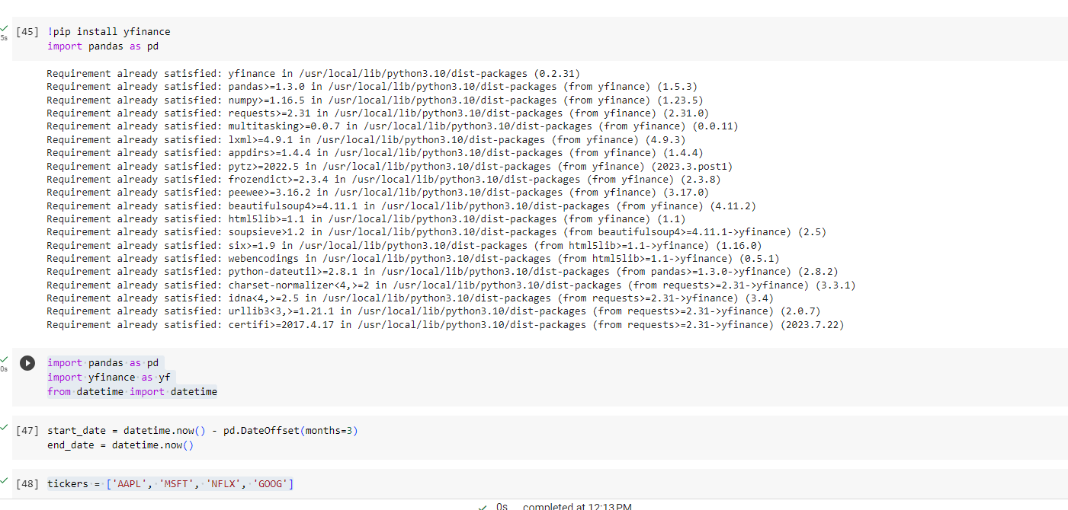

**Define List**

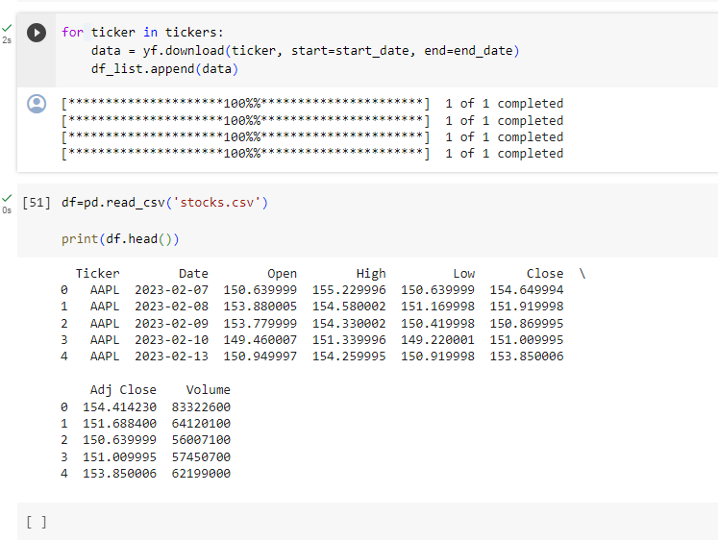

**Head Detail**

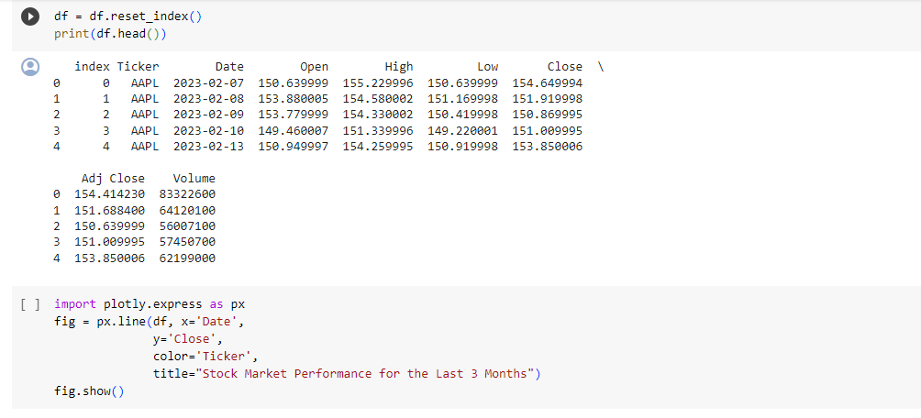

**Explore**

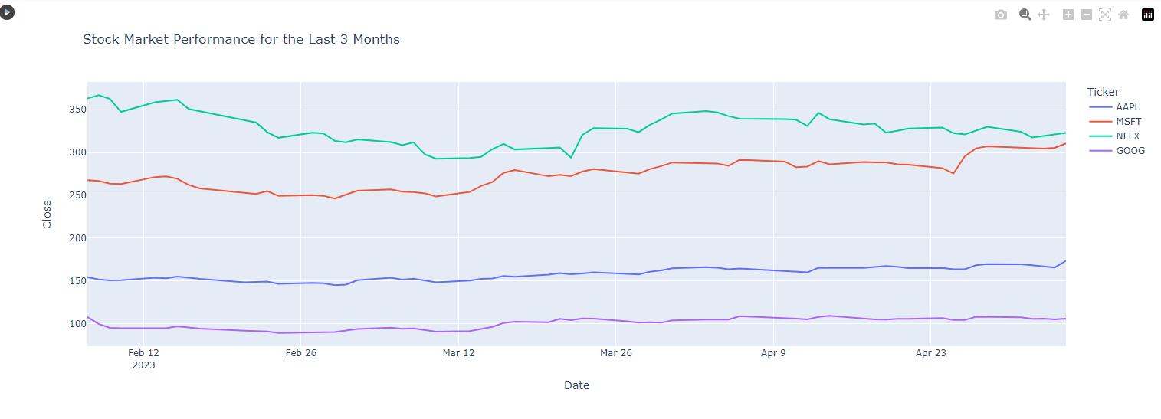

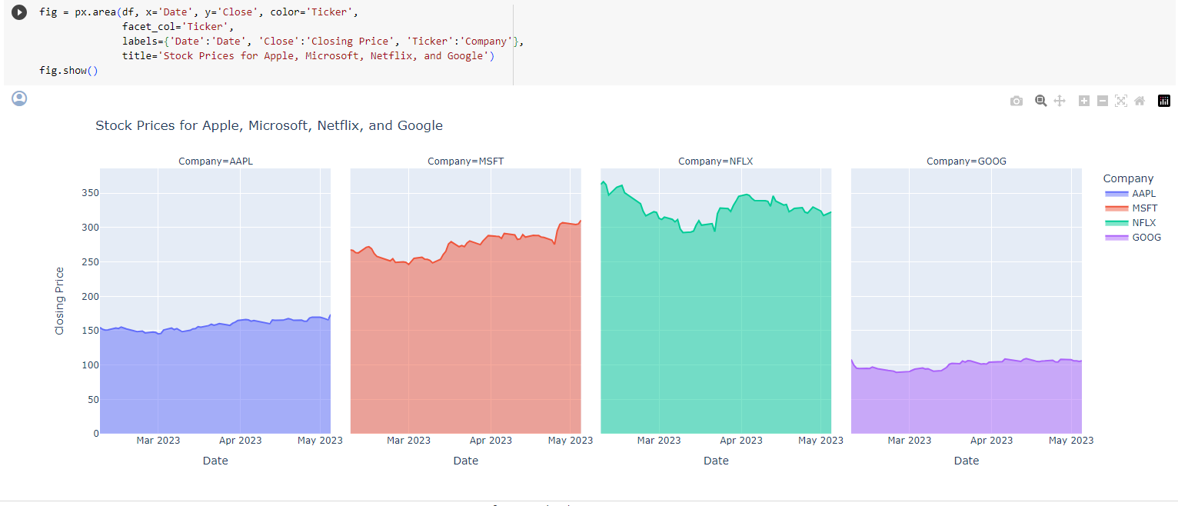

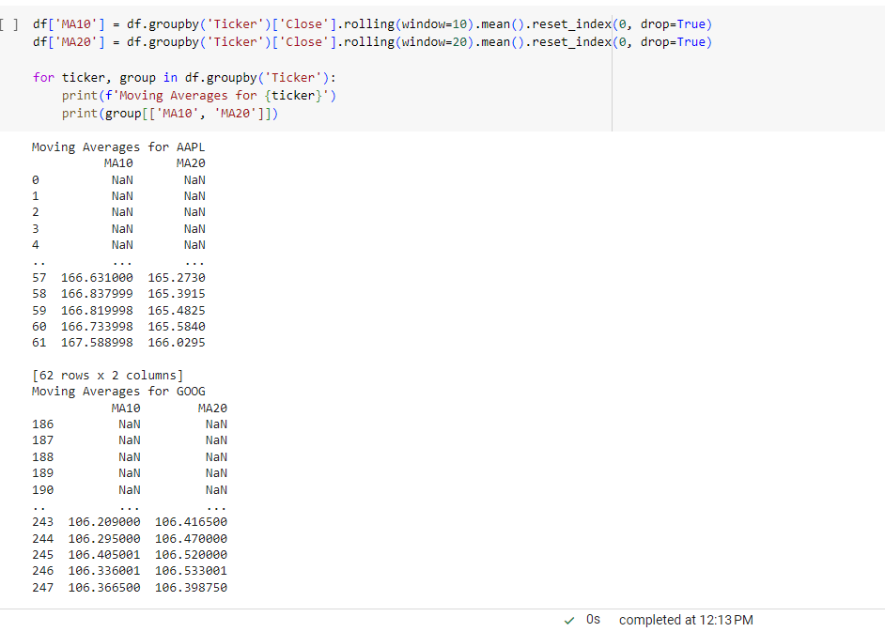

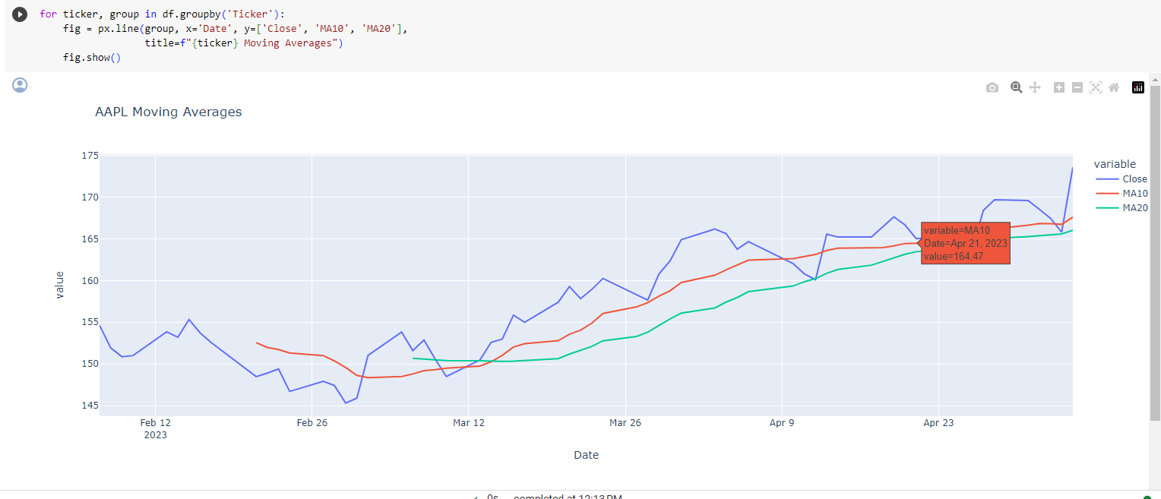

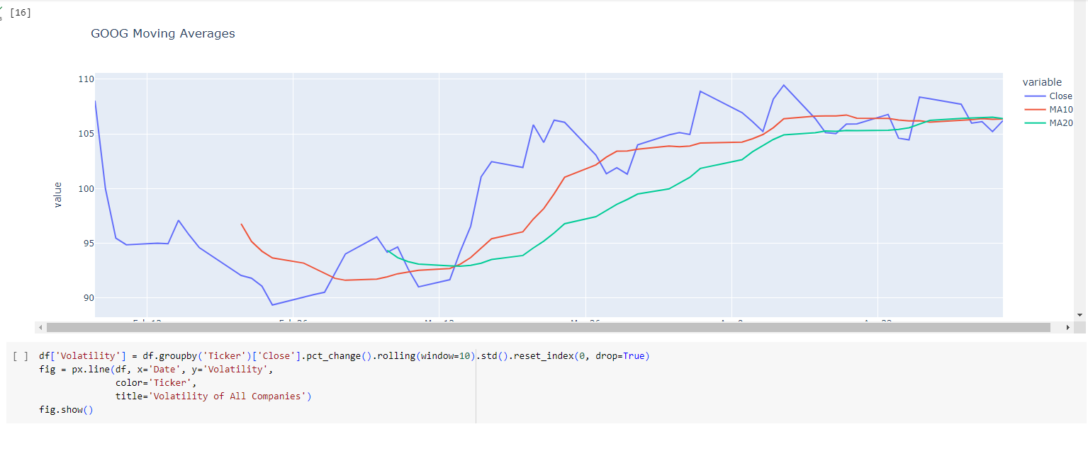

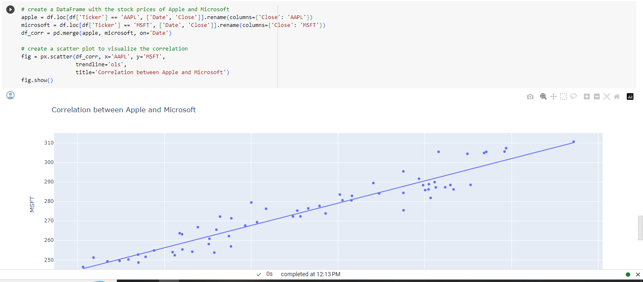

**Future scope**

The future of the stock market holds exciting prospects shaped by technological advancements and evolving investor preferences. Artificial Intelligence (AI) and machine learning are poised to play a pivotal role, enhancing market analysis and decision-making processes. Blockchain technology is likely to bring about increased transparency and security, with the potential for tokenization of traditional financial instruments and the rise of decentralized finance (DeFi) platforms. Quantum computing may revolutionize financial modeling and algorithmic trading. Regulatory Technology (RegTech) will continue to evolve, ensuring compliance and automating reporting. The global stock market is expected to become more interconnected, facilitating international investments and collaboration between exchanges. Sustainable and ESG (Environmental, Social, Governance) investing is gaining prominence, influencing investment decisions. Tokenization of assets, big data analytics, and advanced cybersecurity measures will further shape the landscape. The future also promises personalized and customizable investment strategies, driven by fintech innovations. Collaboration between traditional institutions and fintech startups will foster continuous innovation, while the regulatory landscape will adapt to accommodate emerging technologies. As the stock market continues to evolve, staying attuned to these trends will be key for investors navigating this dynamic financial ecosystem.

**Conclusion**

As the stock market evolves, market participants must stay informed, embrace technological advancements responsibly, and adopt strategies that align with changing market dynamics. Whether an individual investor or a financial institution, navigating the stock market of the future will require agility, continuous learning, and a keen understanding of both traditional and emerging financial principles. The stock market's ability to adapt to these changes will ultimately shape its resilience and significance in the years to come.

Top of Form

GITHUB LINK:

https://github.com/siminikita/data-analytics-project